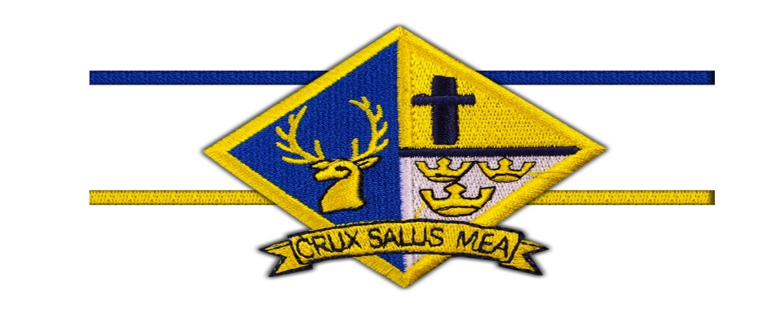

St David’s RC School
Open Day

Wednesday
30th October 2019

Times
9.30am - 10.30am
1.30pm - 2.30pm
