Home learning support for bilingual families

The resources below are useful for everybody but particularly for children/ young people learning English as an Additional Language.

Websites (Primary)

 | World stories  WorldStories is a growing collection of stories from around the world
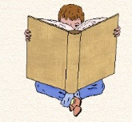 | Magic Keys  Audio books for children of all ages
 | Storynory  Free audio stories with text available
 | Librivox  Free public domain audiobooks - Read by volunteers from around the world
 | Magic Blox  A website with stories for ages in some different languages
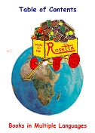 | Children's books online  Stories in different languages
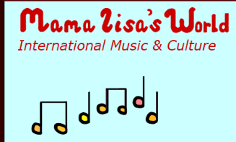 | Mama Lisa's world  Stories and songs in different languages
 | Starfall  Offers free resources to help learning to read. Uses pictures and audio to support
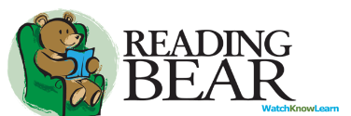 | Reading Bear  Offers a fun learning to read experience, with context to support understanding
 | BrainPOP ELL  Short, animated movies as well as games, quizzes, and interactive features. It encompasses the four main language skills: listening, speaking, reading, and writing
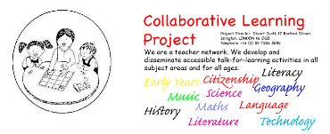 | Collaborative Learning  Accessible talk-for-learning activities for all ages in all curricular areas
 | https://research.kent.ac.uk/theenglishhubforrefugees/resources/  The English Hub for Refugees  English Langue resources for reading, writing and listening & talking

iPad apps

Reading
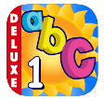  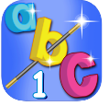   | ABC magic  Reading Magic Spelling magic | P1-4 | Teaches sounds of letters and helps to build words  Teaches the reading and spelling of simple words
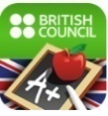 | LearnEnglish Grammar (UK Edition) | All ages | Improve your grammar skills. In multiple languages
Writing
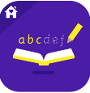 | Letter Workbook Home Edition | P1-3 | Teaches children how to form and write letters
 | Popplet | Upper primary + | (Lite Edition) A planning and mind-mapping app. You can add saved pictures to your plan
 | Quizlet | Upper primary + | Good for key vocabulary, exam revision
Listening & Talking
 | Toontastic | All ages | Create film cartoons using a story arc. Easy to use
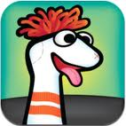 | Sock Puppet | Primary | Create animation with your voice, puppets and backgrounds
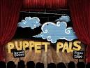 | Puppet Pals 2 app download | Primary | Great for listening and talking activities
 | Explain Everything | All ages | App that lets you make videos and presentations for yourself and others to learn from
Inter-disciplinary Learning
 | Learn English | Primary | Lots of free online games, songs, stories and activities for children. For parents, there are articles on supporting children in learning English, videos on using English at home and information about face-to-face courses around the world
 | CBeebies Activities | Primary | See children prepare for different faith and cultural festivals. Watch clips sing songs and find craft ideas
Secondary

 | https://learnenglishteens.britishcouncil.org/  https://learnenglishkids.britishcouncil.org/ | Learn English Teens and Learn English Kids  improve your English with reading, writing and listening practice, tips for exams, grammar and vocabulary exercises, games and videos
 | https://research.kent.ac.uk/theenglishhubforrefugees/resources/ | The English Hub for Refugees  English Langue resources for reading, writing and listening & talking
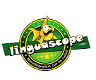 | https://www.linguascope.com/ | Linguascope  language games and activities, organised in over 140 topic areas, are developed to match curriculum requirements

Other Useful tools

 | iTranslate | Middle Primary + | simple, easy to use translator with a variety of languages
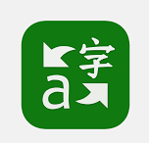 | Microsoft Translator | Middle Primary + | translation and transcription service that lets you have translated conversations across multiple devices. It also has an audio and keyboard function
 | Information about Immersive Reader | All ages | found on Microsoft Word.  Translates written text from English with ability to listen to text in audio format

