Literacy and English
Reading
In P6/7 and we are really looking closely at how fluently the P6 and 7’s can read – can they read with expression, use punctuation and break down trickier words into sounds to figure them out. They will be doing in-depth reading activities weekly to assess their greater understanding of the text. We encourage as much reading at home as possible, the children can always borrow books from the class library. We are currently doing a class novel where the teacher models the correct pace and pronunciation of how pupils should be reading.

Writing
This term writing will have a focus on narrative writing as we start our class novel and reading groups. This term we will be focussing on the 7 key elements involved in narrative writing:
- Characterisation
- Setting
- Theme
- Plot
- Atmosphere
- Figurative Language & Literary Devices
- Point of View

Listening and Talking
Children will always have an opportunity to voice their opinion and work on talking in front of others. They will get opportunities to talk when in their reading group, debating about the class novel, and use their ICT skills to present their PowerPoints or Pic Collage displays to the rest of their peers.
Numeracy and Mathematics
Maths is split into 2 teachings parts which compliment each other – mental maths and numeracy. This builds the mental strategy behind what we are doing in numeracy. This term we will be looking at the 4 basic principles – addition, subtraction, multiplication and division to then use them in other areas such as scale, and coordinates. We will be focusing on the language of maths and how to tackle worded problems.

Religious Education 
We are using the ‘This is Our Faith’ programme for RE. We start every morning with looking at a passage or scripture, understanding it and how it can relate to our faith. In P6/7 we carry on with the Pope Francis Faith Award, this ties in our faith at home, in school and within the Parish. This award helps to prepare us for our Confirmation later in the year.

Science and Social Studies
Children will have many opportunities to explore STEM. In science this term we will be looking classifying living things into plants (flowering and non-flowering), animals (vertebrates and invertebrates), and other groups through knowledge of their characteristics. We will also begin to construct and use simple branched keys which can be used to identify particular plants or animals. This will allow us to identify characteristics of living things and their environment which have contributed to the survival or extinction of a species. Finally, we will look at describing how some plants and animals have adapted to their environment, for example, for drought or by using flight

In Social studies we are learning about The Jacobite rebellion. A day trip to Holyrood Palace will incorporate our learning of this topic.
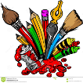
Expressive Arts
Art
Children will have opportunities to be creative and artistic within all their work. We will be creating a variety of artwork related to Scotland. As well as exploring the famous Scottish artists.

Music
Children will get to learn a woodwind instrument every Thursday with a St Augustine’s teacher, Miss McQue from mid- February. There may be an opportunity arising to do an after-school club with Tinderbox where the children can choose any instrument to learn to play or song write on a Friday from 12:25 until 13:30.

Health and Wellbeing
PE for P6/7 is on a Tuesday and Friday. Children can come into school in PE kit for the full day as we cannot use the changing rooms yet.
This term we will continue with the resilience programme and start ‘Keeping myself safe’. This looks at different scenarios in life and the choices we make to keep ourselves safe.

Ethos and Wider Achievements
Being part of St. David’s means that the children learn about ways that we can support other individuals both locally and worldwide. The Rights Respecting School Award enables the children to become confident individuals, responsible citizens, effective contributors, and successful learners.
In P6/7, we will continue to:
- Celebrate our successes and achievements in school in our class and at assembly.
- Celebrate our wider achievements out of school in our class and at assembly.
- Celebrate being a Rights Respecting School and continue to work towards achieving gold status.
- Continue to foster the ethos of our Visions, Values and Aims – ASPIRE. A leader of learning will be chosen each week for being ambitious, spiritual, persevering, inclusive, positive in relationships or equal.
- In P6/7, P7s will have lots of responsibility such as duties, prefect, and house captain roles. They also ‘buddy’ the P1s on a Tuesday to settle them into school life.
Opportunity for Wider Achievements
At St David’s we celebrate our wider achievements out of school in our class and at assembly. If your child has an achievement to share, we would love to hear about it.

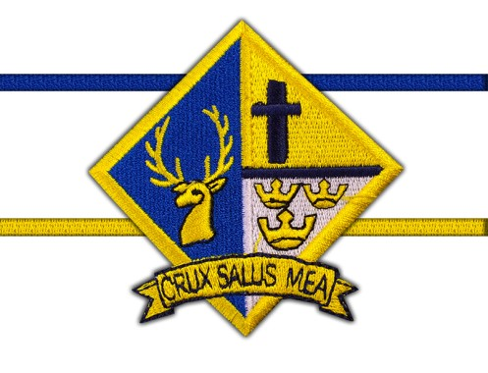

Primary 6/7
Term 2
January -April 2022

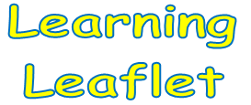

Learning is planned for the children through four contexts: Curriculum Areas and Subjects, Interdisciplinary Learning, Life and Ethos of St David’s as a Community and Opportunities for Wider Achievements.

